**Full Stack Development with MERN**

**HOUSE RENT APPLICATION**

**1. Introduction**

* **Project Title:House rent app**
* **Team Members**:

**1.PRYADHARSHINI.K (413021104030)**

**2.DOMINIC.P (413021104008)**

**3.ANTONY NAYAKA KING.J (413021104301)**

**4.LOGESHWARI.M (413021104020)**

**2. Project Objectives**

The key objectives of this project are:

* To develop an intuitive application for rental property management.
* To enable users to filter properties based on location, price, property type, etc.
* To create a secure system for user data and transactions.
* To provide functionalities like viewing property details, booking, and managing
* leases.

**3. Scope of the Project**

This application targets individuals or businesses seeking rental properties and landlords

wanting to list their properties. It covers:

* Property listings with detailed information and images.
* A search and filtering feature to find properties based on preferences.
* User accounts for landlords and tenants with appropriate functionalities.
* Rent tracking, online payment options, and a notification system for
* reminders.
* Lease agreement management and communication tools.

**4. System Requirements**

Hardware Requirements:

* Processor: Intel i3 or higher
* RAM: Minimum 4GB
* Storage: Minimum 250GB
* Software Requirements:
* Operating System: Windows 10 / Linux / macOS
* Web Browser: Chrome, Firefox, or Safari
* Programming Languages: HTML, CSS, JavaScript, PHP, or Python
* Database: MySQL or PostgreSQL
* Framework: Bootstrap, Django, or Laravel (depending on tech stack)

**5. Modules of the Application**

User Module

* Tenant Registration/Login: Allows tenants to create an account, log in, and
* manage their profile.
* Property Search and Filter: Search functionality based on location, price,
* size, and type.
* Booking and Lease Management: Enables tenants to book properties and
* view lease agreements.
* Admin Module
* Property Listing Management: Enables landlords to add, edit, and remove
* property listings.
* Payment Tracking: Allows tracking of rental payments and setting up
* payment reminders.
* Communication System: Messaging or notification system for landlord-
* tenant communication.

**6. Functionalities**

For Tenants

1. User Registration and Login: New tenants can sign up and create a profile.

2. Search Properties: Search functionality with filters for easy access to desired

properties.

3. View Property Details: Detailed information and images of each property.

4. Rent Payment: Provides options for online payments and reminders.

For Landlords

1. Listing Properties: Add property details, images, and set prices.

2. Manage Rentals: Track rented properties, tenant details, and payment

statuses.

3. Notifications: Send notifications to tenants regarding payment dues or lease

renewals.

1. **Design and Implementation**

The front end of the application is developed using HTML, CSS, JavaScript, and Bootstrap

for responsiveness and user-friendliness. The back end is handled using PHP or Python

Django, and MySQL is used for data management.

**C0DING:**

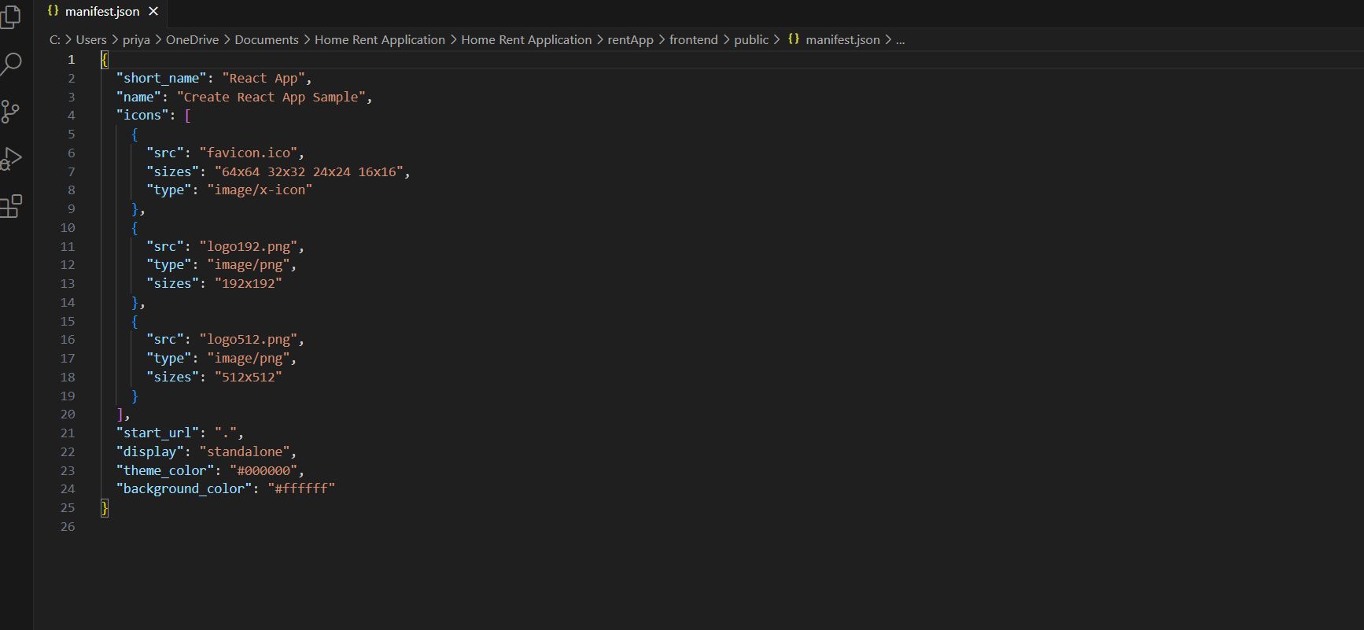

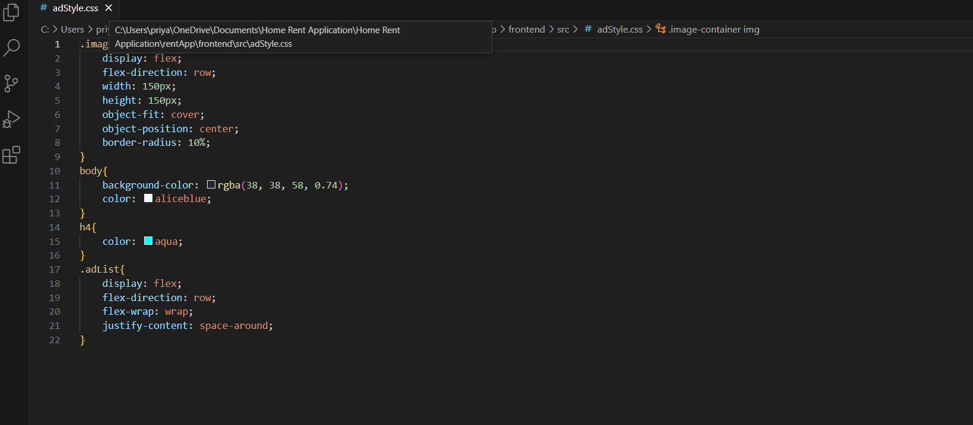

**OUTPUT:**

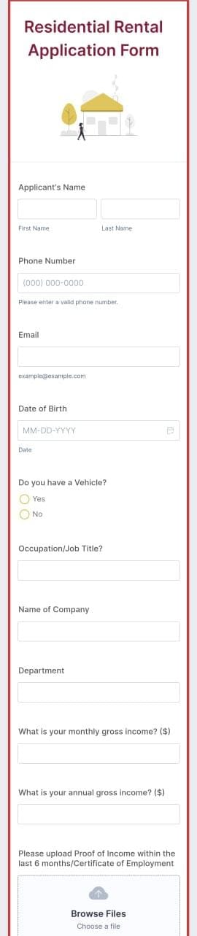

**8. Conclusion:**

The House Rent Application project simplifies the rental process, creating a digital solution

to bridge the gap between landlords and tenants. By incorporating features for listing,

searching, renting, and managing properties, the application provides a secure, convenient,

and user-friendly environment for property rentals.